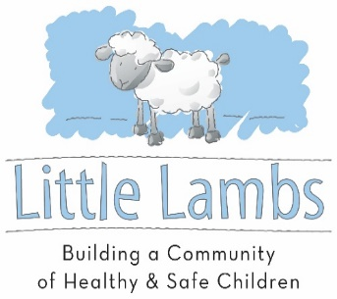
Life Skills Classes at Little Lambs of Evansville

Earn Vouchers for attending classes and use those vouchers to purchase diapers, wipes, kids clothes, car seats and more.
All Little Lambs Classes are FREE and opened to the public.
Caregivers, friends, and grandparents are welcome to attend.
Updated class lists are found on Facebook and our website.

●Weds, Jan 8th at 2:00 to 4:30 pm Meet Community Partners at Little Lambs
Have Medicaid or HIP questions? Do you need Medicaid or Marketplace Insurance? Family Planning Services? Looking for a dentist? Ready to quit smoking? Stop by and have your questions answered.

●Weds, January 15th at 1:00 pm Child CPR and Choking Prevention
This is a free, friends and family CPR class presented by The Women’s Hospital.

●Weds, Jan 29th at 1:00 pm Stop the Bleed: Join us for a training on how to stop life-threatening bleeding. Presented by Lu Weil, Deaconess.

●Saturday, Feb 1st at 10:30 am Safe Sleep Class Presented by Lisa, PA
In this class you will learn what Safe Sleep looks like for Infants. Confused about which cribs and bassinets are safe? Concerned about Rock N Plays being recalled? Need a safe place for your child to sleep? Come to this class and have your questions answered! We can help you find a safe place for your infant to sleep. Free HALO Sleep Sacks at class. This class is offered monthly at multiple locations! Please ask for more information!

●Weds, Feb 12th at 2:00 to 4:30 pm Meet Community Partners at Little Lambs
Have Medicaid or HIP questions? Do you need Medicaid or Marketplace Insurance? Family Planning Services? Looking for a dentist? Ready to quit smoking? Stop by and have your questions answered.

●Weds, February 19th at 1:00 pm Taking Care of Mom Support Group
With Christy, RN from The Women’s Hospital.

●Weds, February 26th at 2:00 pm Block Party Play Date for Kids by Meagan from Purdue Extension

●Weds, March 11th at 2:00 to 4:30 pm Meet Community Partners at Little Lambs

●Weds, March 18th at 1:00 pm Safe Sleep Class Presented by Christy, RN from The Women’s Hospital.
In this class you will learn what Safe Sleep looks like for Infants. Free Sleep Sacks and More!

●Weds, March 25th at 1:00 pm Breastfeeding, Pumping and Going Back to Work or School
Presented by Nancy, RN and Lactation Consultant from the Vanderburgh County Health Department

Car Seat Classes and Inspections by Appointment at Little Lambs’ Car Seat Inspection Station
You may have your child’s car seat checked by one of our Child Passenger Safety Technicians by making an appointment. If you do not have an appropriate car seat we will do our best to help you find a safe one. We have a variety of car seats that may be purchased with vouchers or by a small donation.
Caregivers earn a voucher for every child who has their car seat checked!

Little Lambs 609 SE 2nd St. Evansville, IN 47713 www.littlelambsevansville.com 812-425-5262
We are opened Wednesday 1-5 pm, Saturday 10 to Noon, and by appointment.
Car Seat Help by Appointment Only

